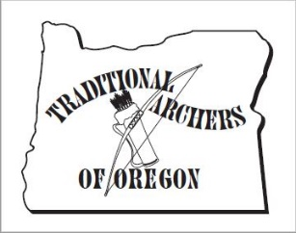
Sponsored By:
TRADITIONAL ARCHERS
OF OREGON

PRESENT THE ANNUAL

BOB BOURET CONSERVATION PROJECT
AND
CHARLIE BARR GOLF SHOOT
Saturday & Sunday, April 11th & 12^{th,} 2020
Happy Ridge on the White River Wildlife Area
Tygh Valley, Oregon

Events: (golf course will be open on Friday for pre-event fun, Saturday evening and all day Sunday)
Saturday-8:00 am till done-participate in work projects with WRWA staff.
Remainder of day- enjoy Happy Ridge with stump-shooting,
shed and digger hunting or archery golf practice.

Sunday- 8:00 am- register, pick up score card, play 18-holes
of archery golf (9 hole course & 9 hole flu-flu course), turn in
score card to registration. Awards for low score and KP’s
at 1:30 pm. TAO “ Thank You Shoot” for work party
participants following awards ceremony
Remember your parking
permit (comes with your hunting license)

Shooting Fees:
TAO MEMBERS – FREE
Non-Members - $10
Yeah-what he said!

Very Primative Camping:
Bring your own – EVERYTHING!

Equipment:
Recurve, Longbow, Selfbow ONLY
Arrows of your choosing

Note: Our golf pro recommends being prepared for any kind
of weather and suggests you bring a variety of arrows that vary
in flight w/blunts, judos or field points on the business end.
Directions:
Take Hwy 197 to Tygh Valley
Head West on Fair Grounds Rd. ~ 5.7 Mi to Happy Ridge

Information: Visit www.taoregon.com or contact: Mike Treat Dave Treat
503-432-9170 503-320-4168
treatmj68@comcast.net dtreat007@comcast.net

